**covariance**

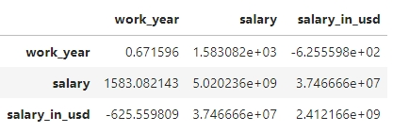

1. Positive covariance: work year and salary have a positive covariance (1583.082), indicating a tendency for salary to increase with work experience.

2. Negative covariance: work_year and salary_in_usd have a negative covariance (-625.559809), suggesting a decrease in salary_in_usd with work experience.

3. Strong covariance: salary and salary_in_usd have a strong positive covariance (3.746666e+07), indicating a close relationship.

4. High variance: salary has a high variance (5.020236e+09), indicating significant spread.

**correlation**

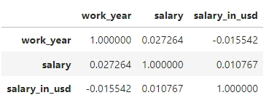

1. Weak correlation: work_year and salary have a weak positive correlation (0.027264).

2. Weak correlation: salary and salary_in_usd have a weak positive correlation (0.010767).

3. Weak negative correlation: work_year and salary_in_usd have a weak negative correlation (-0.015542).

**Variance** **Inflation** **Factor** **(VIF)** **Summary**

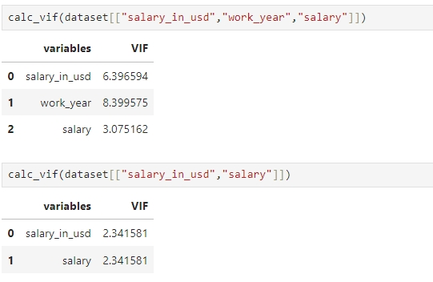

**Interpretation**

1. High VIF: work_year (8.399575) indicates high multicollinearity, suggesting that work_year is highly correlated with other predictors.

2. Moderate VIF: salary_in_usd (6.396594) and salary (3.075162) indicate moderate multicollinearity.

**Insights**

1. Collinearity issue: work_year and salary_in_usd are highly correlated, potentially causing instability in regression coefficients.

2. Redundant information: salary and salary_in_usd may contain similar information.

**Recommendations**

1. Remove work_year: Consider removing work_year to reduce multicollinearity.

2. Combine salary variables: Merge salary and salary_in_usd into a single variable.

3. Regularization techniques: Apply regularization (e.g., Lasso, Ridge) to mitigate multicollinearity.



**Observations**

1. Similar VIF scores for salary and salary_in_usd (2.341581) indicate:

- Redundant information

- High correlation between variables

2. Low to moderate multicollinearity:

- No severe collinearity issues

- Model performance unlikely to be severely impacted

3. Recommendation:

- Merge or remove one of the variables to avoid redundancy